1. **Explain DAX.**

**Ans-**

* DAX stands for Data Analysis Expressions i.e. such expressions or formulas that are used for data analysis and calculations. These expressions are a collection and combination of functions, operators, and constants that are evaluated as one formula to yield results (value or values).
* DAX is a functional language i.e. its complete code is always a function. An executable DAX expression may contain conditional statements, nested functions, value references, etc.
* DAX formulas have two primary data types; Numeric and Non-numeric or Others. The numeric data type includes integers, decimals, currency, etc. Whereas, the non-numeric consists of strings and binary objects.
* DAX expressions are evaluated from the innermost function going to the outermost one at the last.

### **DAX Formula – Syntax**

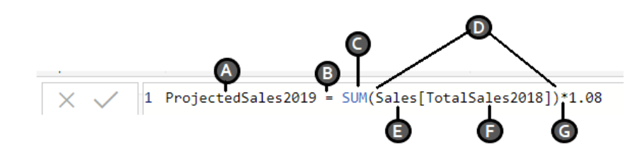

* **A:** It is the name of the new measure (Projected Sales 2019).
* **B:** It is the equals sign (=) which is an operator indicating the start of the DAX formula and equating the two sides.
* **C:** It is the DAX function used to add the values of a given field (Total Sales 2018) from a table (Sales). The function used here is SUM.
* **D:** The parenthesis () is used to enclose and define arguments in an expression. Every function must have at least one argument.
* **E:** It is the name of the table from which a field or column is taken in the formula (Sales).
* **F:** It is the name of the field from which the formula will use the values. For instance, the function SUM will apply itself to the values of the column or field [Total Sales 2018] of the table Sales.
* **G:** It is another operator used for multiplication. Although, the syntax elements from A to F constitute the basic syntax of DAX.

#### **DAX Calculation Types**

* + DAX creates two types of expressions or calculations using DAX in Power BI **Calculated columns** and **Calculated measures**.
  + **Calculated Columns**: The calculated columns create a new column in your existing table. The only difference between a regular column and a calculated column is that it is necessary to have at least one function in the calculated column.
  + **Calculated Measures**: A calculated measure creates a field having aggregated values such as sum, ratios, percentages, averages, etc.

### **DAX Functions**

* + DAX function is a predefined formula that performs calculations on values provided to it in arguments. The arguments in a function need to be in a particular order and can be a column reference, numbers, text, constants, another formula or function, or a logical value such as TRUE or FALSE.
  + Any DAX function always refers to a complete column/field or a table. It will never refer to individual values. If you want to use the functions on separate values within a column, you need to apply filters in a DAX formula.
  + **Type of Dax Function**

##### Date and Time Functions

##### Time Intelligence Functions

##### Information Functions

##### Logical Functions

##### Mathematical and Trigonometric Functions

##### Statistical Functions

##### Text Functions

##### Parent-Child functions

##### Table functions

1. **Explain datasets, reports, and dashboards and how they relate to each other?**

**Ans-**

* **Datasets** is a single set of data created as a result of taking data from multiple data sources. You can use the datasets to create visualizations of different kinds. A dataset can be made of data taken from a single source like an Excel workbook or from more than a data source.
* **Reports** in Power BI is a combination of dashboards having different kind of visualizations relevant to a particular business topic.
* A report shows a complete and structured presentation of data represented in different ways and reveals important insights from the data. Users can easily share reports created on Power BI with other users.
* **Dashboards** are a collection of visualizations offering meaningful information or insights into data.
* Typical dashboards in Power BI are composed of multiple visualizations as tiles. They are single pages from the reports. The dashboards are shareable as well as printable.
* **Relationship** between Dataset, Report and dashboards are **dependent to one each other**, Dashboard visualize from the report which is created by using data in a structured manner with lots of insight which summarise in the report, for any report we need a different type of data that we pull from the different data source.

1. **How reports can be created in power BI, explain two ways with Navigation of each.**

**Ans-**

## **Create a report by using the Report tool**

* + In the Navigation Pane, click the table or query on which you want to base the report.
  + On the **Create** tab, in the **Reports** group, click **Report**.  
    Access builds the report and displays it in Layout view.

## **Create a report by using the Report Wizard**

* + On the **Create** tab, in the **Reports** group, click **Report Wizard**.
  + Follow the directions on the Report Wizard pages. On the last page, click **Finish**

1. **How to connect to data in Power BI? How to use the content pack to connect to google analytics? Mention the steps.**

**Ans-**

* Connect to Google Analytics data using the Google Analytics connector. To connect, follow these steps:
  + In Power BI Desktop, select **Get data** from the **Home ribbon tab**.
  + In the Get Data window, select **Online Services** from the categories in the left pane.
  + Select **Google Analytics** from the selections in the right pane.
  + At the bottom of the window, select Connect.
  + Prompted with a dialog that explains that the connector is a Third-Party Service.
  + Select **Continue**, you're prompted to sign in to Google Analytics.
  + Enter your credentials, you're prompted that Power BI would like to have offline access.

1. **How to import Local files in Power BI? Mention the Steps.**

**Ans-**

* **Import manually local files in power Bi as follows-**
  + In Power BI, click Get Data in the lower left screen.
  + Under Import or Connect to Data > Files, click Get.
  + Click Local File.
  + Choose which file to upload and click Open.
  + Click Upload under Upload your Excel file to Power BI.
  + The message “Your file has been uploaded” should appear.

1. **In Power BI visualization, what are Reading View and Editing view?**

**Ans-**

* There are two modes of interacting with in the Power BI service, **Editing view** and **Reading view**. If you are a *business user*, then you are more likely to use Reading view to consume reports created by others.
* **Editing view** is used by report designers, who create the reports and share them with you. **Reading view** is your way to explore and interact with reports created by colleagues.
* Even in Reading view, the content isn't static. You can dig in, looking for trends, insights, and other business intelligence.
* Slice and dice the content, and even ask it questions using your own words. Or, sit back and let your data discover interesting insights.